
Apr 2025 Issue 3-8



President’s Message:

March proved to be quite a busy month:
- At our March 4th Board meeting we approved the Play Selection Committee's recommended 2025/2026 play schedule.
- We voted to approve the nomination of Nancy Dearborn to fill the vacant Board position.
- We discussed the need to create or enhance committees to allow the competent and coordinated growth of the many facets involved with our club.
Several days after our March Board meeting, I received a startling call from Ray Schiel, our Board Secretary, Readers Ensemble Director and Website Manager. He reported that he was experiencing overwhelming personal issues that would require him to resign from all his club positions. We empathize with Ray and any member when they cannot continue no matter the reason. Of course, we wish Ray only the best and welcome his return whenever he is able.
However, this unfortunate circumstance serves to highlight a serious issue within our club's structure. We cannot rely on only one person to perform these or even much less multiple, critical functions. Anything can suddenly happen to any one of us at any time. We must have committees of members who are trained to stand in to perform a function should the regularly assigned member not be available.
Therefore, please look for and read your emails for notices of committee meetings. If you can contribute to these committees, please attend the meetings. We need your help and your talents.
I would like to give a big "shout out" to the 30+ members of the cast and crew of The 1940’s Radio Hour. This was our first musical presentation since the covid years. The show was a huge success as was evident in that 1703 tickets were sold, which was just 5% less than the total number of allotted seats for all 6 performances combined. A special thank you goes out to the two Directors, Herb Hyland and Linda Shirck, both of whom worked tirelessly to make this show happen.
In addition, I would also like to give accolades to our members who performed so poignantly for our "Song & Story Night 2.0". If you weren't there, you missed an enchanting experience that accorded us with both laughter and tears.
Prior to the entertainment at the March 17th meeting, we conducted the business of approving Nancy Dearborn by unanimous voice vote to fill the vacancy on the Board. We welcome Nancy and thank her for volunteering her services.
As of this writing, we have secured the rights to all 3 approved plays for the upcoming 2025/2026 season. We can announce the names and dates for the first 2 plays, as well as the dates for our Spring musical. However, we are not allowed to announce or advertise in any print form the title or other information about the third play until November 2025. So, I will just say that this production is based on a fairy tale and that it has been performed previously by Players.
Our 2025 Fall play, Farce of Nature, was revealed at the March 17th meeting. Audition dates and times can be found on our website and in a separate section of this newsletter. Please consult the website and check out future emails for the complete 2025/2026 play book.
Thank you,
Greg Engstrom. President

News and Views:
Membership:
If you have not renewed your 2025 membership, you can do so online at https://www.suncityplayers.org/plans-pricing by credit card or at the April Monday Night meeting. If you do not renew by the April meeting, you will have to sign up as a visitor. Visitors are allowed to attend two meetings free of charge but then must become a member after that to continue coming to events.

Sun City Sings!: “A Song of Spring” Concert
Mark your calendars now to attend Sun City Sings! Mixed Chorus Spring Concert on Friday, April 11 at 7:00 PM at American Lutheran Church, 17200 Del Webb Blvd. It is free and open to the public; a $10 donation is appreciated.
The program will include music selections which celebrate the coming of spring and the power of music in our world and lives. “What a Wonderful World” and “Shenandoah” and “The Sound of Music “are among the well-known pieces.
The chorus will present music inspired by contemporary choral composers, including Frank Ticheli’s “Earth Song,” “The Awakening” by Joseph Martin and “Sing Gently” by Eric Whitacre. Composed during the pandemic, Whitacre’s poignant lyrics still resonate today: “Sing gently always, sing as one. May we stand together always, may our voices be strong.”

Sun City Sings! Mixed Chorus
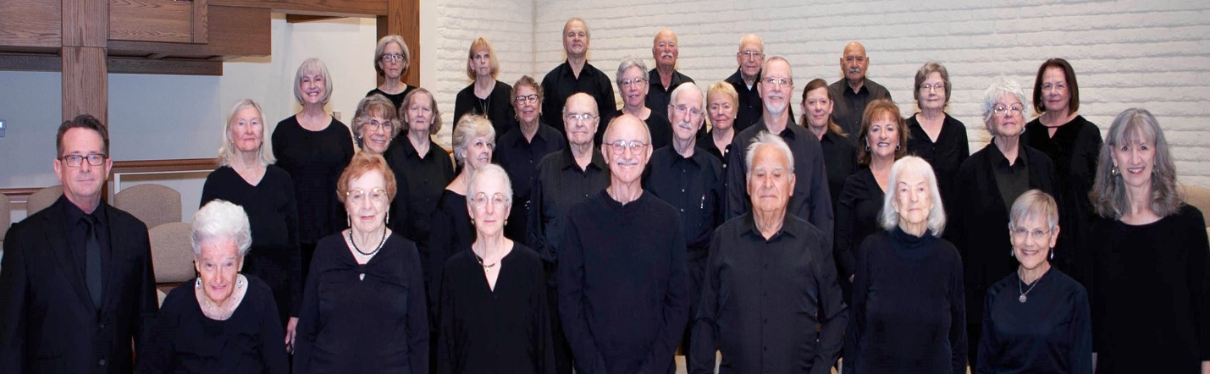

Clubhouse:
Many thanks to Bobby Havens and Celeste Hyland for their leadership in bringing the membership another season of valuable, informative and entertaining workshops. Clubhouse will resume after the summer months.

Readers Theater Ensemble:
Readers Theater classes will continue to be held throughout the rest of this year on every other Saturday of each month at Fairway Recreation Center from 10:00 am to noon in AZ rooms 1&2.
Readers Theater has not only brought in a myriad of new members to our club, but it has also provided us with many talented actors and skilled behind the scenes individuals for our main stage productions.
We look forward to your presence at our next class sessions on April 5 and April 19, 2025.

Monday Night Meetings:
April 21, 2025: “The Sun City Ukelele Club”
The Sun City Ukelele Club became a chartered club in November 2011 and now has over 150 members. They are dedicated to spreading the joy of music, one ukelele at a time, while always having fun. They play and sing a variety of music to include folk, country, rock, and, of course, Hawaiian. They appreciate it when the audience joins in the singing and, if so moved, if they get up and dance.
Table seating will be in order, so please bring refreshments and beverages to share with your table mates. Spring and summer birthdays will be acknowledged with cake and bottled water. Since this will be the last Monday Night meeting until September, we encourage you to attend and bring your guests.


Photos from The 1940’s Radio Hour:
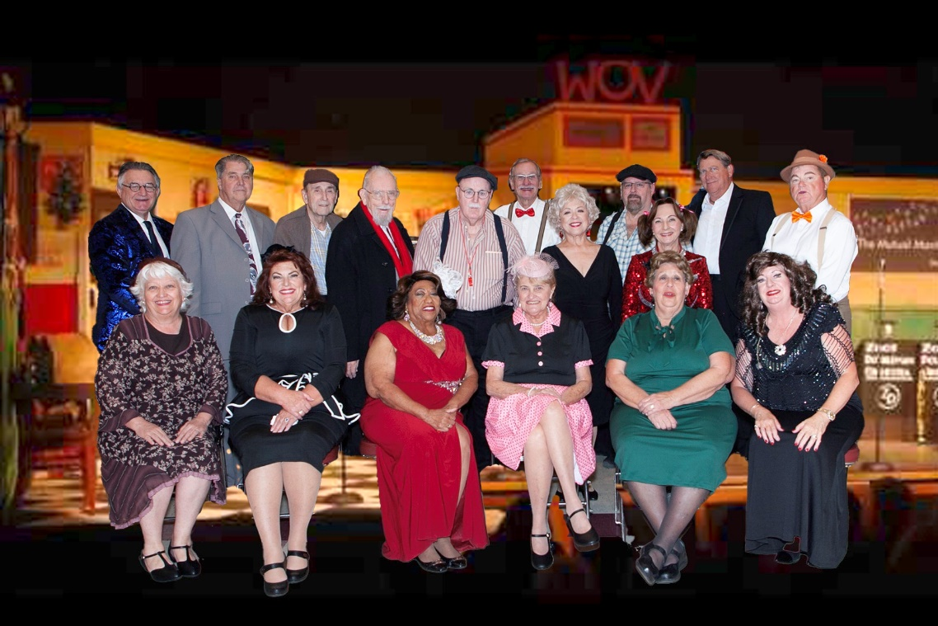

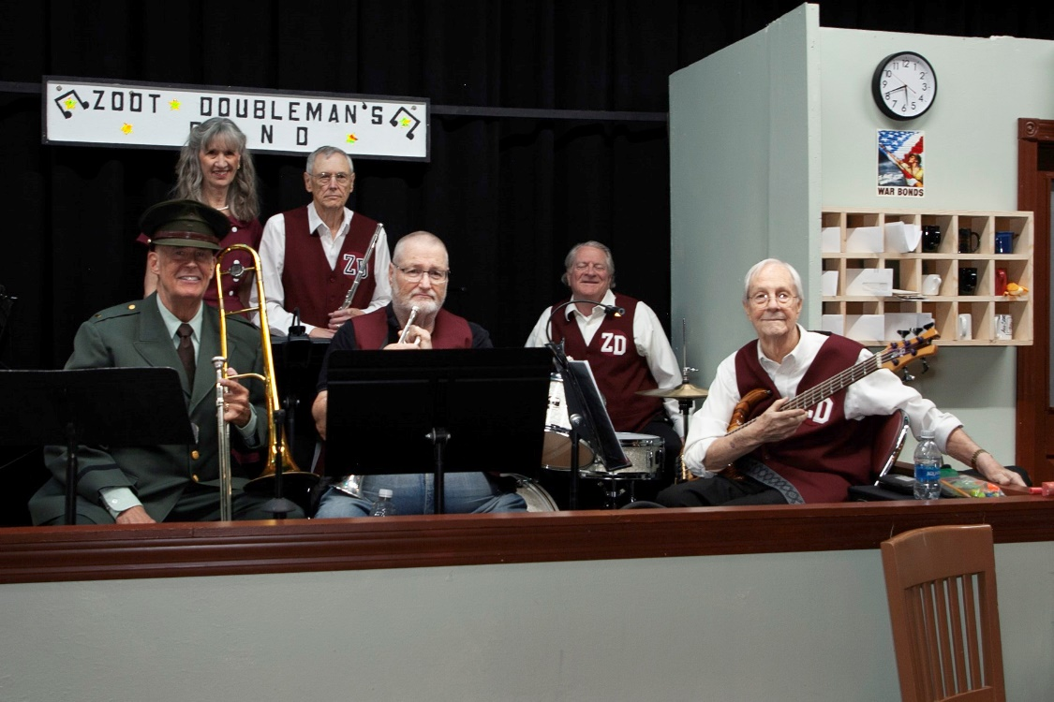

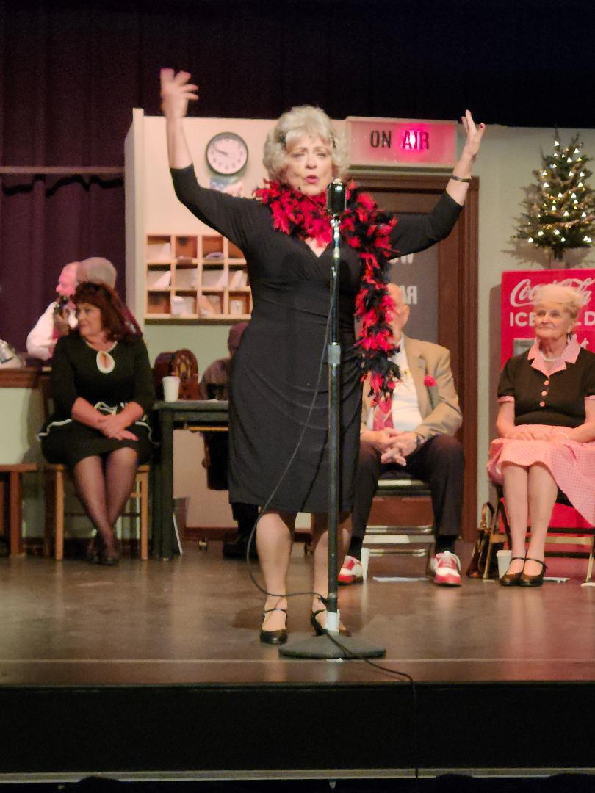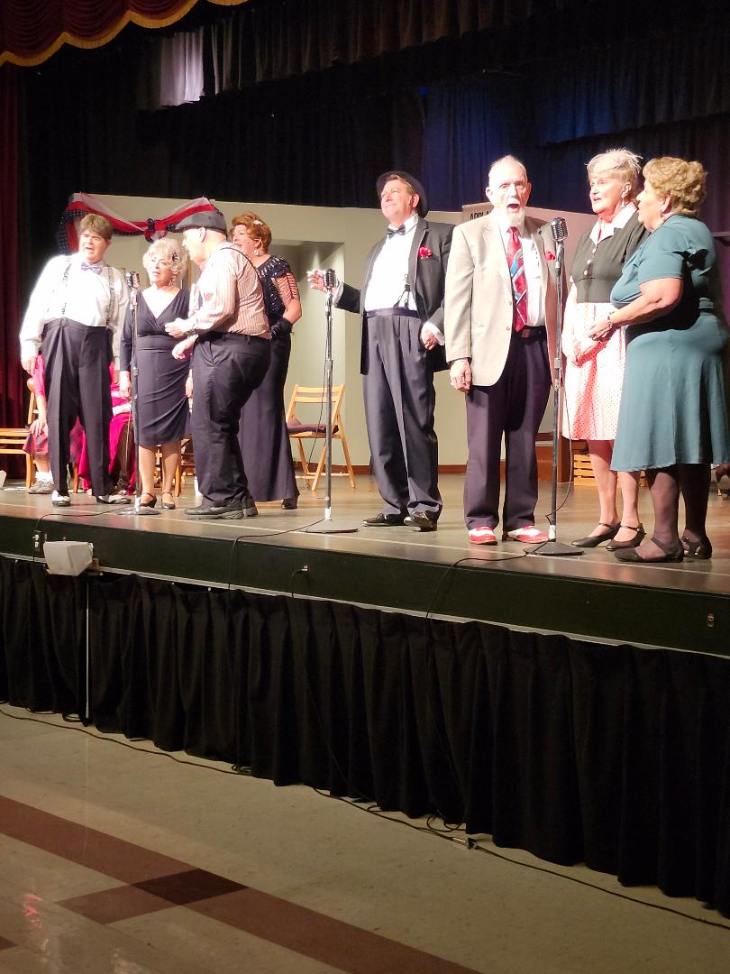
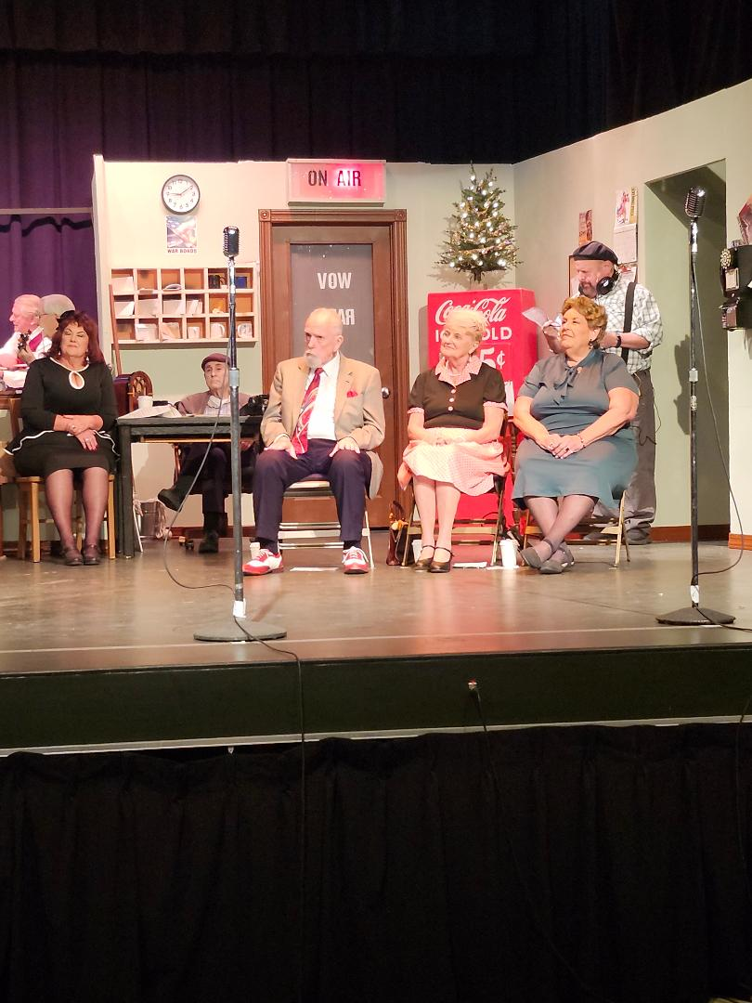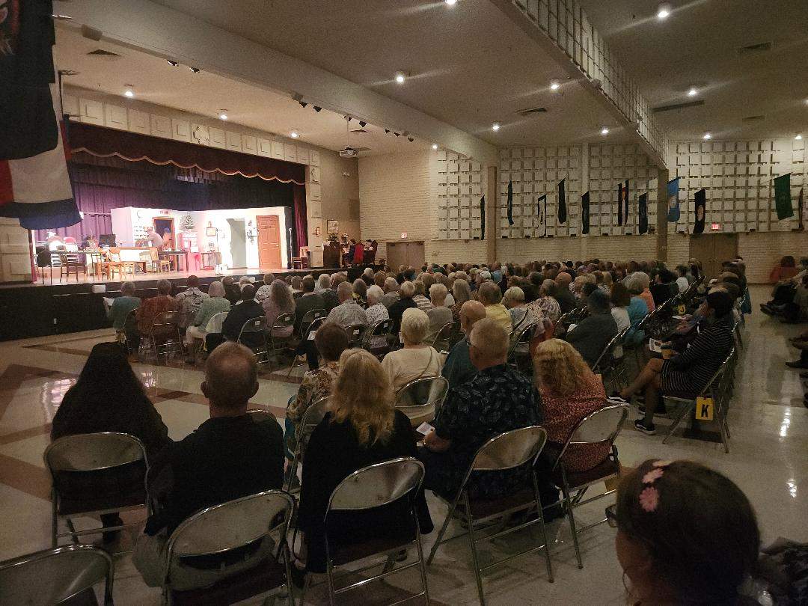

Audition Announcement:



Sun City Players is pleased to announce auditions for our Fall 2025 production, Farce of Nature, directed by Ann Davis, which will take place on Monday, April 14 and Tuesday, April 15, 2025, from 4:00 to 6:00 pm at Mountain View Recreation Center. Auditions will consist of readings from the script.
The play is a hilarious farce which highlights one crazy day in the life of the Wilburn family at their run-down fishing lodge in the Ozarks in Arkansas.
Casting Requirements: 4 men and 5 women for the following roles:

- D. Gene Wilburn (M) – owner of the fishing lodge, southern dialect
- Wanelle Wilburn (F) – D. Gene’s wife, southern dialect
- Maxie Wilburn Suggs (F) – D. Gene’s sister/county sheriff, southern dialect
- Carmine DeLuca (M) – Chicago mobster in Witness Protection Program, some bad Swedish and a southern dialect
- Ty Wilburn (M) – actor son of D. Gene and Wanelle, now from Chicago, so doesn’t need southern dialect
- Jenna Sealy (F) – Ty’s hometown girlfriend, southern dialect
- Sonny Barbosa (M) – ruff big city tough guy, head of Chicago mob
- Lola Barbosa (F) – Sonny’s wife, flashy and sexy, Chicago dialect
- Roxanne Thorne (F) – professional real estate agent
Rehearsal Dates: Starting September 2, 2025
Performance Dates: Nov 7-9 and Nov 14-16, 2025
For more information or to request a script, please email Ann Davis at: anndavis90@gmail.com

Obituary:
Cecilia (Cece) Simonelli, a member of SCPCT until she moved out of Sun City, passed away on March 5, 2025. She appeared in “Mixed Nuts” in 2014.

Volunteers Needed:
We need many individuals to help promote the coming season in the following ways:
1. To contact businesses about placing ads in our performance programs
2. To train as one of our website managers
3. To manage the purchase and sale of merchandise
4. To contact independent and assisted living facilities to promote group sales
5. To join the membership team to oversee registration of new members
6. To contact restaurants to ask for a discount for our patrons
7. To design the play posters for 3 shows
8. To train as light or sound technicians for our club meetings and performances

These are just a few of our specific tasks. There will be more as we develop our entire plan.
Do you have special skills to help with our promotion projects?
Are you interested in helping in any of these ways? Or do you want to pursue another idea that will help us spread the word about our outstanding performances?
Contact Jan Murphy at murphjanet@gmail.com to get involved.

Calendar:
Apr 1: 9:00-11:00 am – Exec Board Meeting – Fairway Rec Center, Rm 133
Apr 2: 9:00-11:00 am – Sun City Sings! Rehearsal – Amer Lutheran Church
Apr 5: 10:00 am – noon – Readers Theater – Fairview Recreation Center, AZ rooms 1&2
Apr 9: 9:00-11:00 am – Sun City Sings! Rehearsal – Amer Lutheran Church
Apr 11: 7:00 pm - Sun City Sings! “A Song of Spring” Concert – Amer Lutheran Church
Apr 14: 4:00-6:00 pm - Audition for Farce of Nature – Mountain View Rec Center
Apr 15: 4:00-6:00 pm - Audition for Farce of Nature – Mountain View Rec Center
Apr 19: 10:00 am – noon – Readers Theater – Fairview Recreation Center, AZ rooms 1&2
Apr 21: 7:00 pm – Monday Night Meeting with entertainment by The Sun City Ukulele Club - Mountain View Rec Center

Executive Board:

President: Greg Engstrom (920) 988-7339
gregengstrom0@gmail.com
Vice President: Bill Cherry (585) 278-5209
wcherry5731@gmail.com
Secretary: Vacant

Treasurer: Jean Balk (602) 451-2748
jeank28@outlook.com
At Large: Tad Daughters (Compliance) (510) 207-0092
tadcnslt@lycos.com
At Large: Janet Murphy (602) 799-2227
murphjanet@gmail.com
At Large: Nancy Dearborn (319) 573-5877
nancydearbornmusic@gmail.com

Club Information:
Theater Location:
Mountain View Recreation Center
9749 N. 107th Ave Sun City, AZ 85351
Box Office:
Jim Beaudin: 623-233-4611
suncityplayersboxoffice@gmail.com
Web Address:
suncityplayers.org
Web and Media:
scpct.webkeeper@gmail.com
General Mail:
(623) 866-5602
scpct.generaloffice@gmail.com
Playbill Editors:
Norman and Rhonda Krinsky
normandrhonda45@yahoo.com
520-906-6246

